**Verde River Runoff Safety Tips**

* This river stretch is bordered by both Public and Private land. Do not get off the river unless at a designated river access point (Clear Creek or Beasley Flats)
* Pack it out! Don’t litter. If you have the opportunity to pick up trash, pack it out with you!
* Obey the Rules and Regulations set for the event, and follow State and Federal Boating policies.

**Be Respectful**

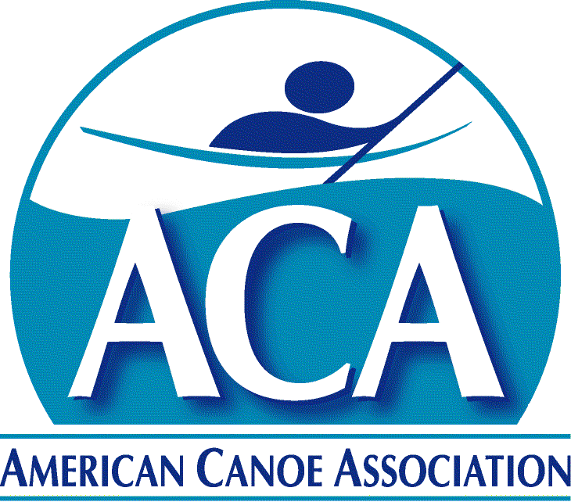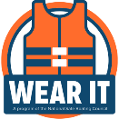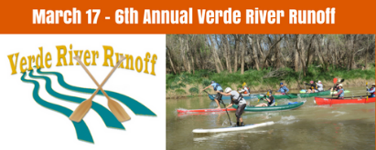

* The river is always the boss, go with the flow and stay sharp around those bends.
* Lookout for fellow paddlers. Pushing paddlers in to hazards or causing them to flip is not cool, and very dangerous.
* Don’t stop learning. Take the time to learn about how to navigate the river safely and about the hydrology of river features.
* Share the STOKE! Paddling is a group activity!! High five fellow racers, safety crews, and organizers.
* Give back- Consider helping out with local stewardship projects
* #WEARIT! Make sure you wear your USGC approved PFD at all times while on the water. Ensure it fits properly by fastening all buckles and tightening all straps.
* Helmets are strongly encouraged on the river! Protect what’s important.
* Leashes for SUP are not recommended for this stretch.
* HYDRATE and EAT WELL!! Drinking water before, during, and after is key to feeling good after paddling! Eating a good breakfast is also key!
* Dress to swim. Let’s face it, we’ve all been there. Make sure the clothing you wear protects you for those pesky in water experiences.
* Know what’s downstream! It’s suggested to run the river before the event to become familiar with the course.
* Do not stand in the river. Float downstream feet first until in calm water.

**Be Prepared**

**Be Humble**