DIRECTIONS for RACE DAY
TO PUT IN/ RESGISTRATION (WHITE BRIDGE)
From the I17, head east on 260 for approximately 4.4 miles. Follow event signs. Once you cross over the first bridge, TURN RIGHT at the next street just after the bridge.
Google Maps: https://goo.gl/maps/gSK8UCvJqQH2

TO 5mi FUN FLOAT PUT IN (CLEAR CREEK)
From White Bridge/ Registration, turn left on 260 and drive west for approximately 1.6 miles. Turn left on to Oasis Rd (at top of hill), and follow the road down. Turn right on to Salt Mine Rd (at the T intersection). Drive approximately 5.5 mi to Clear Creek Day Use on left hand side of road.
Google Maps: https://goo.gl/maps/xVrsX1eS6662

TO TAKE OUT (BEASLEY FLATS)
From White Bridge/ Registration, turn left on 260 and drive west for approximately 1.6 miles. Turn left on to Oasis Rd (at top of hill), and follow the road down. Turn right on to Salt Mine Rd (at the T intersection). Drive approximately 7.8 mi to a T-intersection. Turn left staying on paved road. Once you reach a small residential area, turn left and stay on main road for approx. 2.5 mi, until you reach Beasley Flats (end of the road).
Google Maps: https://goo.gl/maps/QdawQANez8o
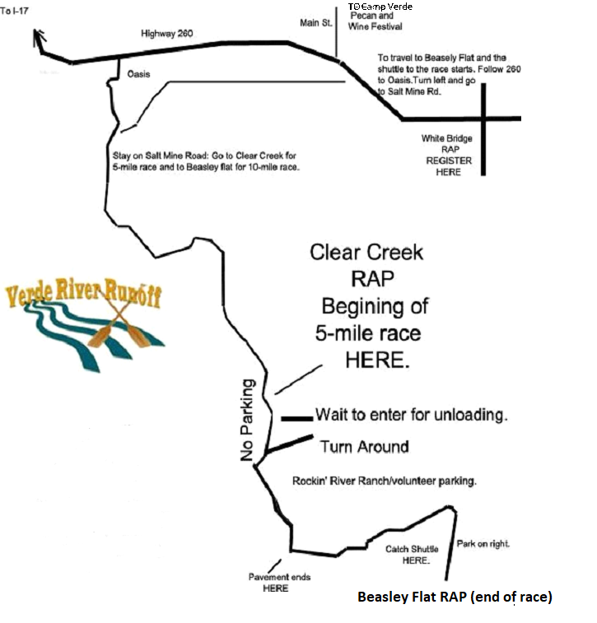
Please Note:
Space is limited at all locations. Please follow parking volunteers for parking guidance.
There is NO parking at White Bridge or Clear Creek.
There is a shuttle from the take-out to bring you back to your starting point.

